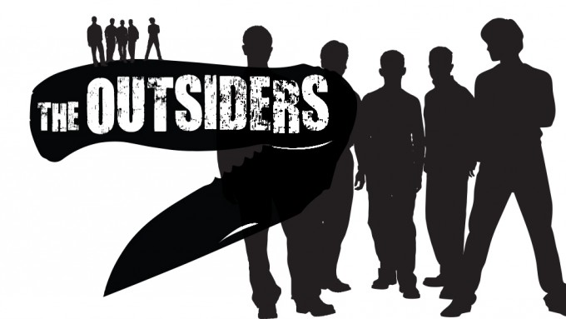

**Chapter One**

**Discussion Questions**

1. What can you infer about Ponyboy’s world, or the setting? Find three quotes to support your answer.
2. Where do Ponyboy and his friends and family come from, socially? Find three quotes to support your answer.
3. Describe how Hinton has used an effective blend of first person narrative, action, and dialogue in the first chapter.
4. Explain the effect the blend of first person narrative, action, and dialogue has on the reader.
5. Find three examples of language use that is specific to the Greasers and explain what effect it has on other characters and the reader.
6. Why is the “gang” important to Johnny?
7. What does Ponyboy means on page 18 (end of Ch 1) when he says “I lie to myself all the time. But I never believe me.”