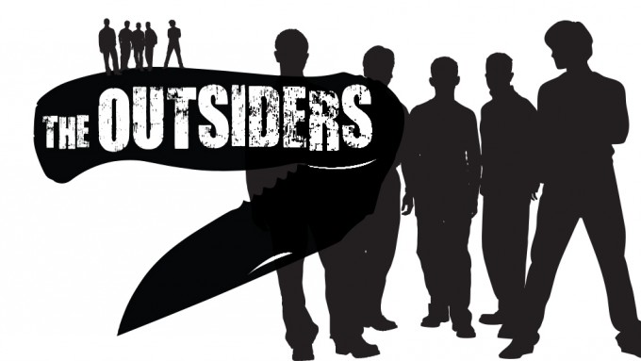

**Chapter Two**

**Discussion Questions**

1. Make a list of all violent incidents in Chapter 2.
2. To what extent does Hinton make shockingly violent incidents normal in order to explore how it affects the young people involved?
3. Why are Ponyboy and Johnny embarrassed when Dally is rude to the Soc girls?
4. Why did Cherry and Marcia leave their boyfriends at the drive-in? What does this say about their character?
5. Why doesn’t Ponyboy like referring to Sodapop as a dropout?
6. “Dally was there, too, swearing under his breath, and turning away with a sick expression on his face. I wondered about it vaguely. Dally had seen people killed on the streets of New York’s West Side. Why did he look sick now?” (p32-33) Explain Dally’s reaction.
7. What did Cherry mean when she said, “Things are rough all over”?