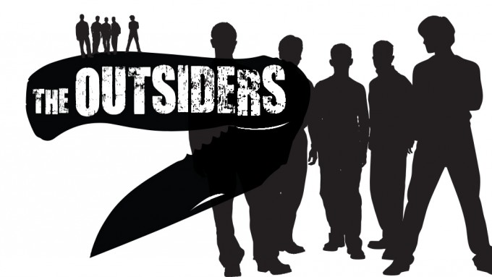

**Chapter Three**

**Discussion Questions**

1. What is the irony of Cherry saying that she is searching for something else despite having nothing else to want?
2. Why has Cherry used the sunset as a link between them? What can the reader infer about the fact that Cherry is now too busy to look at sunsets but Ponyboy isn’t?
3. What is ironic about Cherry’s final words after all she has seen and heard? “I could fall in love with Dallas Winston. I hope I never see him again, or I will.” (p 46) Why is she in danger of falling in love with Dally?
4. What is ironic about Johnny’s parents not caring and Ponyboy trembling at the thought of facing Darry? (p 49)
5. What does Cherry explain as the difference between the socs and the greasers?
6. Why does Johnny like it better when his father is hitting him?
7. At the end of the chapter, how does Hinton foreshadow that bad things are to come? Use quotes to support your answer.